**Fenway CDC takes on a new name and expanded mission**

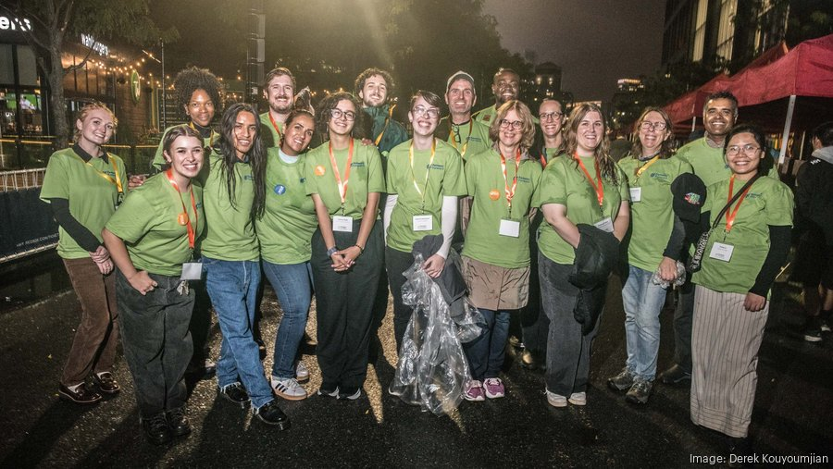Fenway Forward's staff wears shirts showing off its new name and logo at the Taste of the Fenway event. Derek Kouyoumjian

By [Grant Welker](https://www.bizjournals.com/boston/bio/42132/Grant+Welker) – Reporter, Boston Business Journal, Sep 29, 2025

The Fenway Community Development Corp. — commonly known as the Fenway [CDC](https://www.bizjournals.com/boston/organization/centers-for-disease-control-and-prevention) — is turning to a new name to reflect a changed mission.

It is now Fenway Forward, a shorter, alliterative name that also helps avoid confusion with a different CDC.

“People thought we were part of the Centers for Disease Control. And post-Covid, that was much more top-of-mind for people,” said Steven Farrell, the group’s executive director.

Bottom of Form

Fenway Forward’s new name comes as the nonprofit is broadening its strategic plan to include not only more housing options but also workforce development and block parties to help neighbors meet one another. A community leadership program will train residents on civic involvement.

“Community development is not just homes,” said Farrell, who joined Fenway Forward last year. “It's the leadership and vitality of people who live here and their economic security and stability.”

Discussions surrounding the new strategic plan also uncovered a belief among many, Farrell said, that the nonprofit should be more bold in its mission at a time of uncertainty around so much of what the government can do on housing.

“We were thinking of a new logo or a new name to reflect the boldness we had heard about throughout the process," he said.

Fenway Forward has built 525 units already that house about 850 people. Another 230 units are in the works.

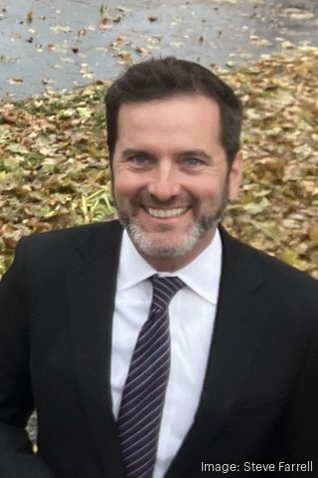

Steve Farrell is the executive director of the community development nonprofit Fenway Forward. Steve Farrell

The 51-year-old organization is also looking to expand housing not only in its home neighborhood, but also on Beacon Hill. Earlier this month, it opened its first new ground-up residential project in 20 years, [a 27-unit building on Burbank Street](https://www.bizjournals.com/boston/news/2025/09/11/boston-nonprofit-opens-new-residential-project.html).

The city has several community development corporations that assist with affordable housing and economic opportunities, but none in Back Bay or Beacon Hill, so Fenway Forward stepped in. The project at 27-29 Hancock St. will total 15 units.

Other projects with which Fenway Forward is involved include a 24-unit development at 112 Queensberry St. in Fenway, a single-story building that last hosted a laundromat. The project still requires permitting and financing.

A project on Hemenway Street is planned to include six condominiums, with for-sale units a rare option for affordable developments. Fenway Forward has produced only 18 such condos otherwise.

“It’s extraordinary that there are so few,” Farrell said of affordable condo opportunities.