Fenway Nonprofit Rebrands and Redoubles Housing Focus
By Steve Adams | Banker & Tradesman Staff | Sep 29, 2025
Fenway Community Development Corp. has roots in an infamous 1970s arson-for-insurance payoffs ring that prompted neighborhood residents to organize and demand officials take action.
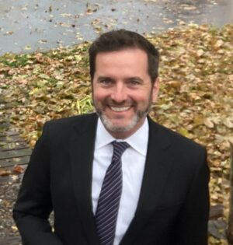
Their efforts led to prosecution of landlords who torched rundown apartment buildings while arson investigators looked the other way.
Today the neighborhood faces a different source of displacement threats, in ever-rising housing costs and uncertainty about federal funding for affordable housing projects. Fenway Forward, the CDC’s new name, reflects its new focus.
“The big takeaway was the encouragement for us as an organization to be bold,” said Steve Farrell, executive director of Fenway Forward. “That is in the midst of a lot of uncertainty coming from Washington, D.C. and the change of administration with the policy and funding shifts.”
Steve Farrell. Photo courtesy of Fenway Forward
The new name is accompanied by a four-year strategic plan. It reflects hundreds of comments from the community during focus groups and meetings led by a 12-member planning committee over the past year.
“They set bold goals around workforce development, expanding local community organization and increasing the number of affordable homes in the neighborhood,” said Farrell, who was named the organization’s leader in 2024. “We need to do more, they said. We’ve had success as an organization and they trusted us, which means a lot to me as a relatively new executive director.”
Over its 51-year history, the organization developed and acquired 522 housing units that are currently occupied by 850 people. In recent years, it has stepped up its development activity despite the scarcity of sites and fierce competition for those that become available.
This month, it held a ribbon-cutting ceremony marking completion of Burbank Terrace, the organization’s first ground-up development project in more than two decades. The project at 72 Burbank St. includes 27 income-restricted apartments.
In 2024, partnering with the Planning Office of Urban Affairs, the organization acquired the 109-unit Our Lady’s Guild House at 20 Charlesgate, where it plans renovations while preserving the apartments’ long-term affordability.
And at 112-114 Queensberry St., a former laundromat property will be redeveloped as a 6-story apartment building totaling 24 units.
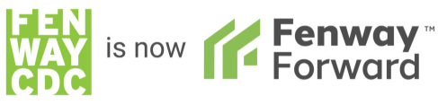
Image courtesy of Fenway CDC
The organization also was designated by the developer of a Beacon Hill luxury condominium project as recipient of inclusionary development policy payments, enabling it to pursue creation of 15 affordable condominiums on Hancock Street.
The nonprofit’s new four-year plan calls for Fenway Forward to expand its advocacy for housing justice and guiding development, significantly increase the supply of affordable and sustainable homes, advocate for low- and moderate-income residents to remain in the neighborhood and increase visibility of the CDC’s programs.
Personal and professional connections by Fenway Forward’s 18 staff members and 13 board members are critical in finding leads for potential acquisitions, Farrell said.
“They are all eyes and ears on the ground helping us deliver on our mission,” he said. “We pursued a property owned by a committee member’s dentist. You never know where the connection is going to come from that is going to yield some affordable housing.”

