**Boston nonprofit completes first residential project in 20 years**

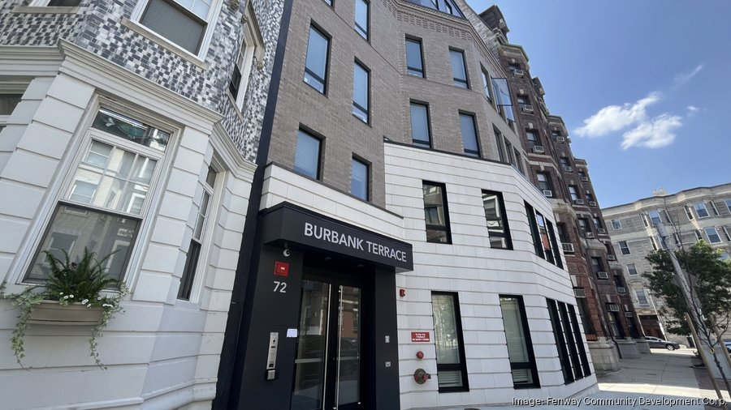Burbank Terrace at 72 Burbank St. in Fenway, is the first ground-up residential project from the Fenway Community Development Corp. in 20 years. Fenway Community Development Corp.

By [Grant Welker](https://www.bizjournals.com/boston/bio/42132/Grant+Welker) – Reporter, Boston Business Journal, Sep 11, 2025

The Fenway Community Development Corp. celebrated the completion of its newly-opened residential building on Wednesday, its first ground-up construction project in two decades.

The building is next-door to the nonprofit's own office building, where a surface parking lot long stood as a missing piece in the Fenway neighborhood’s row after row of apartment buildings.

Of course, it isn’t as simple as buying a plot, lining up permitting and financing, and getting a project done — especially in Boston.

The opening of the 27-unit Burbank Terrace development capped off a project that began with community meetings in 2018. The project began a city permitting process, and the following year won city approval and bought the site. A groundbreaking took place in 2022.

The six-story building was completed last fall and opened to tenants in January. It has 41 residents in all. All units include affordability restrictions.

The project was aided by a series of funding sources, including from the city and state and the Community Economic Development Assistance Corp. The Fenway Community Development Corp. has a group of other housing properties including 97 units at the Newcastle-Saranac development on Columbus Avenue and 36 units in its own headquarters building on Burbank Street.