City, Fenway CDC Celebrate Opening of Burbank Terrace in East Fens
September 19, 2025
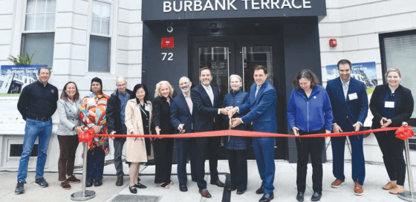
The City of Boston and the Fenway Community Development Corporation (CDC) joined local elected officials and residents on Wednesday, Sept. 10, to celebrate the opening of Burbank Terrace Apartments, which has created 27 new income-restricted apartments in the East Fens neighborhood.
“Fenway is a great neighborhood, and ensuring affordable housing keeps it strong,” said Sheila Dillon, Chief of Housing. “These affordable homes stabilize the community and create long-term opportunities for residents. Fenway CDC seized this chance to make a meaningful difference, and the City was proud to support the effort.”
In 2021, with support from the City, State, and other key partners, Fenway CDC purchased the 72 Burbank St. property from a private developer. Pre-approved zoning helped shorten the development timeline by more than a year, allowing the team to deliver 27 new homes more quickly.
“Making Burbank Terrace a reality required collaboration among City, State, and private partners,” said Steven Farrell, Executive Director of Fenway CDC. “Families living here now have guaranteed affordable homes for years to come thanks to these collective efforts.”
Burbank Terrace replaced a 3,500 square foot, dilapidated parking lot with a seven-story building featuring eight studio apartments, seven one-bedroom apartments, and 12 two-bedroom apartments. Homes are affordable for residents earning between 30 percent and 60 percent of the Area Median Income (AMI).
The apartments are designed for comfort and convenience, with premium finishes, a community room, a kitchen, a lounge area, workspaces, and on-site emergency maintenance. The building is within walking distance of Fenway Park and easily accessible by MBTA.
“Community Preservation Act funds are critical to creating and preserving affordable housing,” said Thadine Brown, Director of Community Preservation. “Burbank Terrace exemplifies community-driven, sustainable development that strengthens neighborhoods for the long term.”
The project was made possible through a partnership of public, quasi-public, private, and nonprofit entities. Funding included support from the Mayor’s Office of Housing, the State’s Executive Office of Housing and Livable Communities, the Community Economic Development Assistance Corporation (CEDAC), and the Massachusetts Housing Partnership (MHP). The Life Initiative (TLI) provided acquisition and predevelopment loans, Eastern Bank supplied the construction loan, and WNC contributed tax credit equity.

